Doodle Doodle

Game Design Document

Team Ark

Jihwan Oh

Beomgeun Choi

Contents

Game Concept 3

High Concept 3

Summary 3

Game Mechanics 3

Player movement 3

Health and Damages 4

Clear and Game over conditions 4

Game Characters 4

Painter (Player) 4

Monsters (Enemies) 4

Game Resources 5

Tool list (Weapon list) 5

Color list 6

Item list 6

Game Environment 7

Maps 7

Structures 7

Visual Design 8

UI Design 9

Camera Movement 9

Audio Design 9

Sound Effects 9

# Game Concept

## High Concept

‘Doodle Doodle’ is 2D platform game. Player will be a painter who can draw pictures on the screen. Player has many different drawing tools such as brush, pencil, eraser, etc. Also, player can change the color of brush to change the type of attack. Player needs to drawing lines or pictures to fight with other monsters. Doodling to fight!

## Summary

‘Doodle Doodle’ is 2D platform game. The world of ‘Doodle Doodle’ is in a large white paper, and player will be a painter who can draw lines or pictures on the screen. Player can collect many different drawing tools such as brush, pencil, eraser, etc. Each tool has different attack form and effects. Also, there are colors of the brush tools and player can change the type of attack with it.

There are many different monsters and landmarks to interact, so player need to plan different tactics according to diverse situations. Player will spend a certain amount of ink while drawing, so player can fulfill it at the fountain of ink.

# Game Mechanics

Player is painter who can draw the line or picture to the screen. There are various type of drawing tools with various effects, so player need to use those functions to fight with enemies.

## Player movement

### Movement

Move with WASD keys on the keyboard

### Drawing

Mouse click and drag

### Jump

Spacebar

### Way to Attack

Player will draw the line with ink . Player will have such amounts of ink and spend it while drawing. There are two ways to gathering the ink. The first, it will automatically be filled by time. And the second, player can fulfill perfectly with the fountain or pump. Player can draw some objects and can interact with them but needs to limit amount of ink to maintain it.

## Health and Damages

Player has 100 life points at the beginning. It could increase or decrease with items. Player’s health will be damaged depending on enemies’ attack status. Player’s defend status also enhanced during the game play.

## Clear and Game over conditions

### Clear condition

There will be many different monsters in each room. Kill the all of monsters in each map and go to the boss room. Then need to fight with boss. player do not have to kill every rooms to go to the boss’s room. If player kill the boss, then the door for next stage will open.

### Game over Condition

When player health is 0 by attacks of enemies.

# Game Characters

## Painter (Player)

This is player who can draw the line or objects for the game. Player can control this character. Player needs to use various drawing tools with various situations, and tool on the back will change depending on player’s current tool.

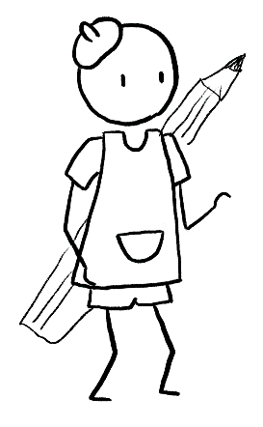

Player

## Monsters (Enemies)

There will be three stages in game. Each stage has specific monsters and boss.

# Game Resources

Player only have pencil as primary weapon. Also, there are treasure chests in  map. These chests are not only could be found around the map, but also could be provide as award of each stage. (Some chests will be hidden)

## Tool list (Weapon list)

Each tool has different effects, ink consumption, and thickness. Only pencil cannot change the color of the line.

### Pencil

Primary weapon. Spend least amount of ink per drawing.

### Colored pencil

Line is thicker than pencil. Spend more amount of ink than pencil.

### Marker pen

Line is little thicker than pencil. Spend same amount of ink as colored pencil. Only can draw on the drawable area which is painted as white board. Line drawn by marker will be an object and affected by gravity.

### Brush

Can attack multiple enemies simultaneously. Line is very thick. Spend lots of amount of ink.

### Eraser

Can erase lines or objects drawn by player. Cannot delete enemies or structures.

### Paint Bucket

Can fill the area (must have closed) of paint. Spend most amount of ink. Enemies will get damage over time in these areas.

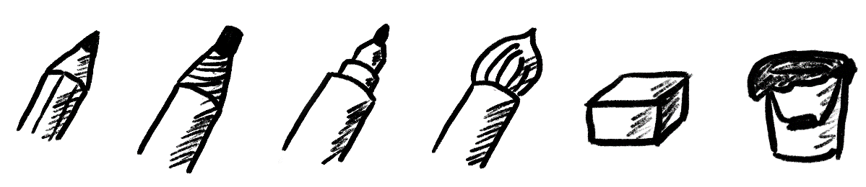

Drawing tools of player. The order is same with list

## Color list

Player can change the color of drawing tools except the pencil and eraser. Each color has different effects.

### Red

Type is fire. Enemy and player are on fire when touch this color of attack.

### Green

Type is poison. Enemy and player get poison when touch this color of attack. They will be damaged over time.

### Blue

Type is ice. Enemy and player are frozen when touch this color of attack. They will move slowly.

## Item list

There are some items. Unlike tools, player need to spend one when he/she want to use.

### Paint Balloon

Fill with white paint which make specific drawable area. Kind of grenade, so player will spend 1 per each when throw.

### Keys (Red/Green/Blue/Yellow)

Each chests and doors sometimes require proper key to open. player can check the color of key to open the chest with color of lock on it.

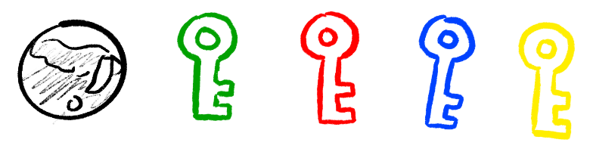

Paint Balloon and Keys

# Game Environment

## Maps

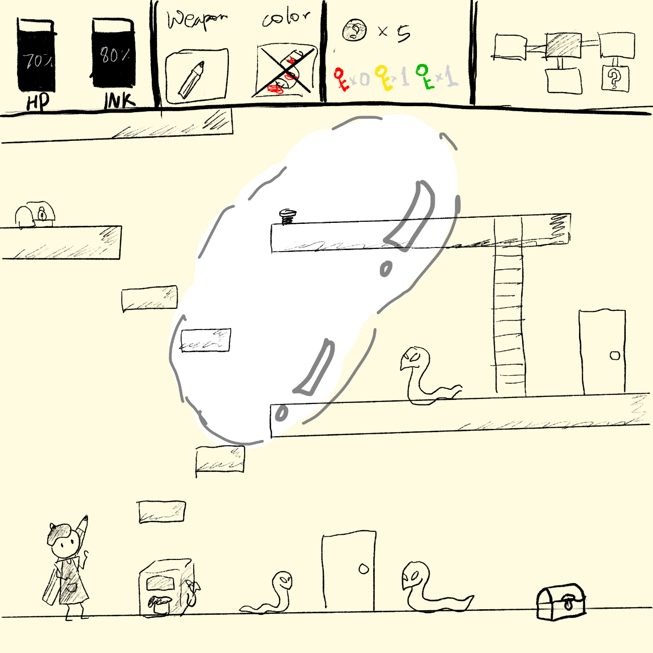

*Basic Design of Map. Also, can check UI*

Background color of the map must see as note. There will be white bright colored area which looks like white board. This area is drawable area for the marker pen. Player only can draw the line and create objects with marker pen.

## Structures

There are various structures player can interact with during the game play.

### Paint station pump

Player can fill the all of ink at this station.

### Spring

If player jump on this spring, player can jump much higher.

### Door

This is door for next stage. Doors will open when player kill all the enemies in a map.

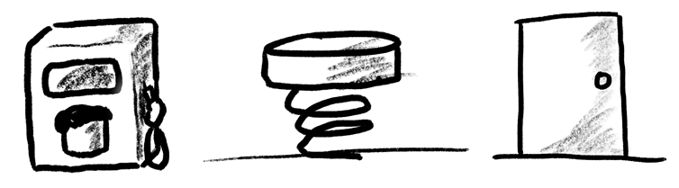

Pump, Spring and Door

### Chest

In this chest, there will be awards or traps. Player can get a tools or items with this chest. Player can find chests during game play and can get for the reward of boss.

### Spikes

This hurt player when player contacts with them.

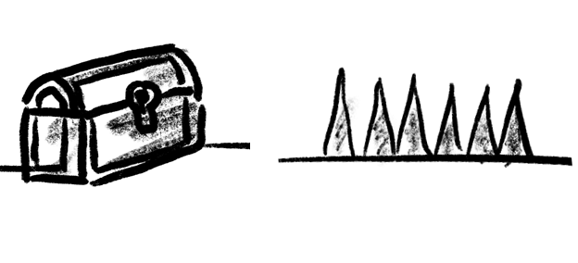

Chest and Spikes

# Visual Design

“Doodle Doodle” is, as you can see in a title, composed with doodles. The game is playing in a note, so background will look like a note or some paper. Also, other monsters and characters also looks very simply because they are also doodles.

Each drawing tools have different texture, so need to visualize it properly. Each draw will automatically disappear with time.

## UI Design

UI is placed with top of the screen. UI is divided into four sections and each section has different function. Introduction will start from left to right.

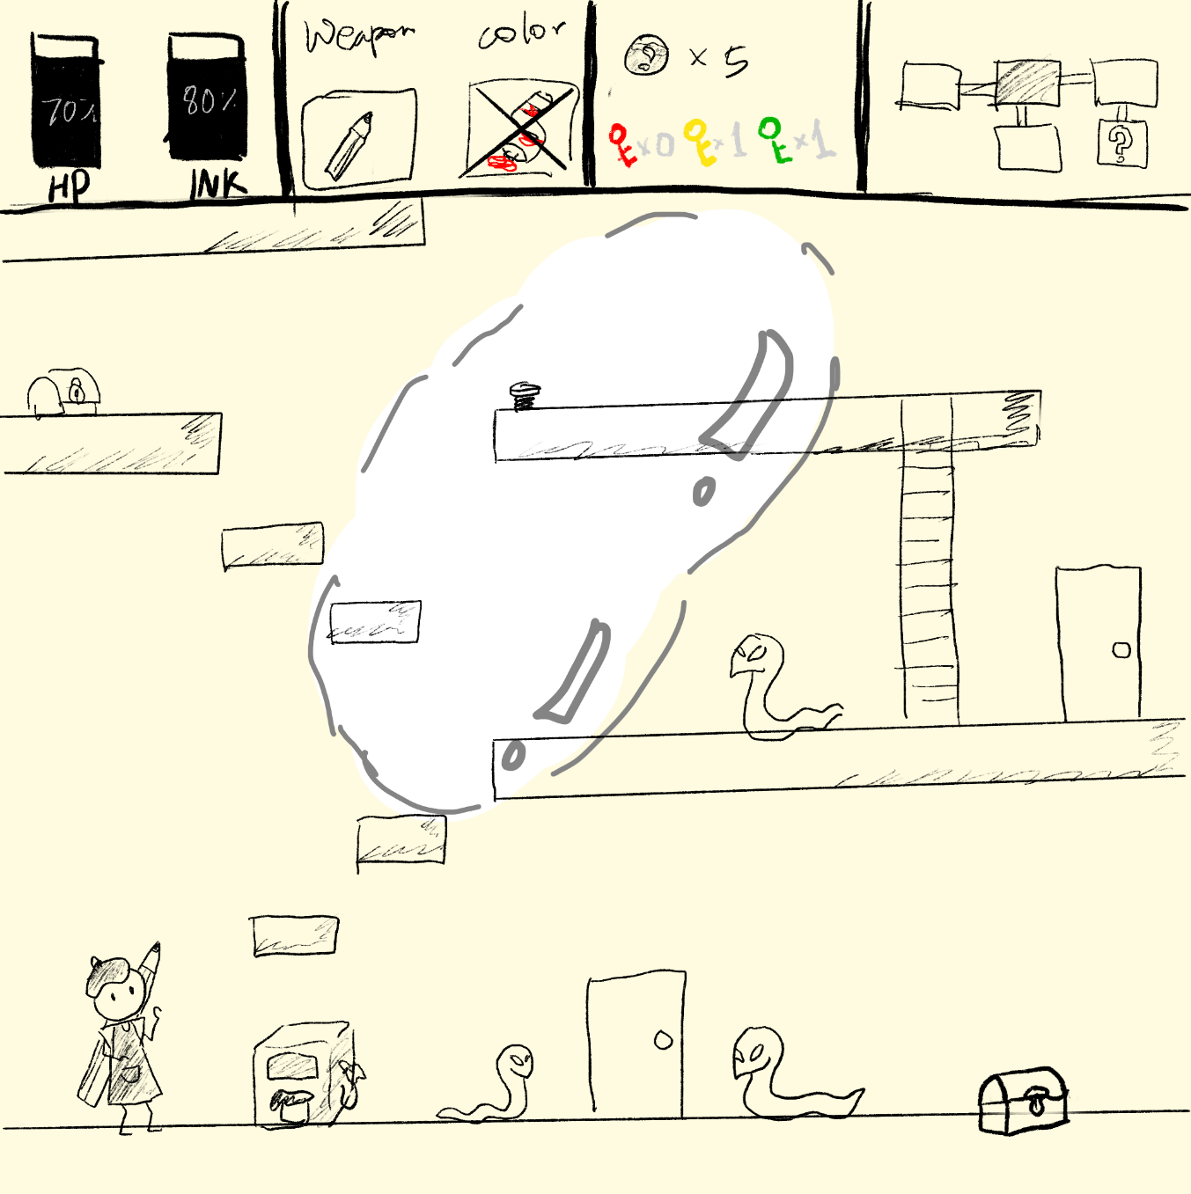

*There are 4 sections in UI*

### Health-Ink Section

First section of UI. This area shows the amount of health and ink of player with gage bar.

### Weapon Status Section

Second section of UI. There are two squares in this section. Left square show an image of player’s current weapon, and right square show an image of paint tube to show the color of tool. This will be blocked when player use both the pencil and the eraser as weapon because they do not use color.

### Item status section

Third section of UI. Player can check the number of paint balloons and keys he/she has.

### Map Section

Fourth section of UI. Player can see entire map he/she visited. Player can check current room and can see unvisited area.

## Camera Movement

Camera will follow the player during the play time. Camera is clamped when player go to end of each direction.

# Audio Design

## Sound Effects

There are many drawing tools in the ‘Doodle Doodle’ and they are all already existing in the world. Therefore, need to use specific sounds for each tool.